

Newfield School
CARE & CONTROL POLICY
(incorporating Physical Restraint)

Reviewed by S Furlong, Deputy Head Teacher Sept 2024
Date of next review: September 2025

`The use of Positive Handling to support the management of physically challenging behaviour`

The policy has been developed in response to DfE non-statutory advice, and staff concerns regarding `The Use of Reasonable Force’ (July 2013) and taking into account the Education inspectors Act 1996 – Section 93, paragraph 550a.

`The Use of Reasonable Force’ (July 2013) states:

The term ‘reasonable force’ covers the broad range of actions used by most teachers at some point in their career that involve a degree of physical contact with pupils. Force is usually used either to control or restrain. This can range from guiding a pupil to safety by the arm through to more extreme circumstances such as breaking up a fight or where a student needs to be restrained to prevent violence or injury.‘
Reasonable in the circumstances’ means using no more force than is needed.. As mentioned above, schools generally use force to control pupils and to restrain them. Control means either passive physical contact, such as standing between pupils or blocking a pupil's path, or active physical contact such as leading a pupil by the arm out of a classroom or difficult / volatile situation. Restraint means to hold back physically or to bring a pupil under control. It is typically used in more extreme circumstances, for example when two pupils are fighting and refuse to separate without physical intervention. School staff should always try to avoid acting in a way that might cause injury, but in extreme cases it may not always be possible to avoid injury to the pupil or member of staff

Who can use reasonable force?
- All members of school staff have a legal power to use reasonable force
- This power applies to any member of staff at the school.
- It can also apply to people whom the SLT team has temporarily put in charge of pupils such as unpaid volunteers or parents accompanying students on a school organised visit

When can reasonable force be used?
- Reasonable force can be used to prevent pupils from hurting themselves or others, from damaging property, or from causing disorder.
- In a school, reasonable force is used for two main purposes – to control pupils or to restrain them.

The decision on whether or not to physically intervene is down to the professional judgement of the staff member concerned and should always depend on the individual circumstances.

The following list is not exhaustive but provides some examples of situations where reasonable force can and cannot be used.

Power to search pupils without consent
In addition to the general power to use reasonable force described above, head teachers and authorised staff can use such force as is reasonable given the circumstances to conduct a search for the following “prohibited items”:
- knives and weapons
- alcohol
- illegal drugs
- stolen items
- tobacco and cigarette papers
- fireworks
- pornographic images
- any article that has been or is likely to be used to commit an offence, cause personal injury or damage to property.
Reasonable Force cannot be used to search for items banned under the school rules.

Separate guidance is available on the power to search without consent
The policy should be read in conjunction with other school policies relating to interaction between adults and pupils, notably, Child Protection and Safeguarding, Health and Safety, Behaviour and Special Educational Needs.

The policy has been prepared for the support of all staff who come into contact with pupils and for volunteers working within the school to explain the school`s arrangements for care and control. Its content is available to mums, dads, carers and pupils. A statement about the School`s Behaviour policy is made to parents in the School website. This statement includes information on the use of reasonable force.

The policy makes frequent references to Team Teach. This is training in how to safely manage young people and is committed to reducing the need for physical restraint through de-escalation and risk reduction strategies, approved by BILD (British Institute of Learning Disabilities). Newfield School acknowledges our legal duty to make reasonable adjustments for disabled children and children with special educational needs (SEN).
Positive handling is a holistic approach, involving policy, guidance, management of the environment and deployment of staff. It also involves personal behaviour, diversion, defusion and de-escalation. Restraint is only a small part of the framework.

The training promotes least intrusive positive handling on a continuum of gradual and graded techniques and has been developed to rely on biomechanical efficiency (the body’s physiology) rather than physical force. None of the techniques rely on the application of pain or any form of “locks” for control This training has local authority support.

Purpose of policy:

Good personal and professional relationships between staff and pupils are vital to ensure good order in our school. It is recognised that the majority of pupils in our school respond positively to the behaviour leadership practised by staff. This ensures the well-being and safety of all pupils and staff in school. It is also acknowledged that in exceptional circumstances, staff may need to take action in situations where the use of reasonable force may be required in a reasonable, proportionate and necessary way to protect the best interests of the individual concerned (least intrusive and least restrictive for the shortest time to keep people safe)
Newfield School acknowledges that physical techniques are only part of a graduated response to behaviour management. However, any actions taken are with the best interests of the child as the paramount consideration, taking into account the United Nations Convention on the Rights of the Child. This means it is the first thing we think about and it takes precedence over all other considerations

Every effort will be made to ensure that all staff in this school:

- Clearly understand this policy and their responsibilities in the context of their duty of care in taking appropriate measures where reasonable force is necessary, and
- Provide appropriate training to deal with these difficult situations. Training will include bi
-annual Team Teach Training and regular discussions and debates in staff meetings.

Implications of the policy :

Section 93 of the Education and Inspections Act 2006 enables school staff to use such force as is reasonable in the circumstances to prevent a pupil from doing, or continuing to do, any of the following :
- Committing any offence (or, for a pupil under the age of criminal responsibility what would be an offence for an older pupil )
- Causing personal injury to, or damage to the property of, any person (including the pupil himself);
- Prejudicing the maintenance of good order and discipline at the school among any pupils receiving education at the school, whether during a teaching session or otherwise. (Section 93 of the Education and Inspections Act 2006 makes it clear that force may be used to prevent behaviour that prejudices the maintenance of school discipline regardless of whether that behaviour would also constitute a criminal offence ).

The staff to which this power applies are defined in Section 95 of the Act. They are:
- Any teacher who works at the school;
- Any other person whom the Head has authorised to have control or charge of pupils, including support staff such as teaching assistants, learning mentors, administrative staff, ICT Technician and site manager.

Individual members of staff cannot be required or directed to use physical restraint. However, as teaching and non-teaching staff work in `loco parentis` they should always operate with an appropriate `Duty of Care`. Should the school`s policy not be adhered to by individuals, it is not unforeseeable that claims of negligence could be levied against them. Duty of care includes observing and reporting difficult situations when a pupil is in crisis and physical restraint is required.

The application of any form of physical control places staff in a vulnerable situation. It can only be justified according to the circumstances described in this policy. Staff therefore, have a responsibility to follow this policy and to seek alternative strategies wherever possible in order to prevent the need for physical intervention.

Team Teach and staff training stress that reasonable force will only be used as a last resort when all other appropriate behaviour management strategies have failed or when pupils, staff or property are at risk.

Behaviour Leadership and Accountability
A member of SLT is responsible for monitoring of behaviour and safety. Teaching staff will monitor and amend half termly PHPs, IBPs and Positive Handling forms to identify trends and communicate to a member of the senior leadership team and governors to decide on next steps.

Definitions of Positive Handling :

No legal definition of reasonable force within a school`s context exists, however for the purpose of this policy and the implementation of it in Newfield reasonable force may be defined as `using the minimum degree of force necessary for the shortest period of time to prevent a pupil harming himself, herself, others or property.`

The scale and nature of any physical intervention at Newfield `must be proportionate to both the behaviour of the individual to be controlled and the nature of the harm they might cause`. (DfES/DOH Guidance for Restrictive Physical Interventions, July 2002). Our use of reasonable force is contextual to our setting; that is, that reasonable force used would be expected to be less with a child in a school setting, than if as an adult, you were assaulted and have to resort to defending yourself out of the school setting.

This policy does more than simply outline the use of physical intervention at Newfield, it aims to provide a transparent overview of how we use physical contact to both care for and, where appropriate control our pupils. Working within the philosophy of `Every Child Matters` with a particular focus in relation to the strands of `staying safe` and `enjoying and achieving`, our Care and Control policy describes the acceptable physical interaction between staff and pupils on a daily basis. Based on the principles of moving from least intrusive to more restrictive holding we have divided interaction into three definable areas.

Physical Contact:

Situations in which physical interaction occurs between staff and pupils to either care for pupils who may be distressed or have severe and profound learning disabilities, or in subject areas such as physical education in order to promote inclusive learning opportunities and deliver the National Curriculum. In addition staff will also use positive touch to comfort pupils and as part of the PSHCE/social curriculum in order to teach them more appropriate ways of seeking attention. Where possible, staff will always endeavour to use the `friendly hold` as defined in Team Teach training. Any positive handling used is in the best interests of the child having followed a dynamic risk assessment of the situation. Reasonable Force used is proportionate (to age, size, gender, medical conditions, physical disabilities, history, and child’s understanding)

Physical Intervention:

This may be used to divert a pupil from a destructive or disruptive action, for example guiding or leading a pupil by the arm with little or no force. The techniques implemented here will include `turn, gather, guide, and the `friendly hold`. The important factor within these situations is the compliance of the child as a result of the intervention. No positive handling documentation is required to be filled in; however, it may be advisable to add to the incident report the details of the interventions taken

Physical Control and Restraint/Restrictive Physical Intervention:

This will involve the use of reasonable force when there is an immediate risk to pupils, staff or property. It is important to note that the use of `reasonable force` should be seen as a last resort. All such incidents are recorded, stored and filed in the Head teacher`s office.

The following techniques are accredited by Team Teach and authorised for staff to use by the senior leadership team. Whenever possible these will be used :

- Guide and deflect
- Friendly Hold
- Single Elbow (One person)
- Single Elbow (Two people)
- Double Elbow (One person)
- Double Elbow (Two person)

As indicated, the level of compliance from the pupil determines whether or not the interaction is an intervention or a control/restraint. If in doubt, then staff should always record the incident using the school`s standard recording form, a copy of which is included at the end of this document.

Underpinning values:

Everyone attending or working in this school has a right to:

- recognition of their unique identity;
- be treated with respect and dignity;
- learn and work in a safe environment;
- be protected from harm, violence, assault and acts of extreme verbal abuse.

Pupils attending this school and their mums, dads or carers have a right to :

- individual consideration of pupil needs by the staff who have responsibility for their care and protection;
- expect staff to undertake their duties and responsibilities in accordance with the school`s policies;
- be informed about school rules, relevant policies and the expected conduct of all pupils and staff working in the school;
- be informed about the school`s complaints procedure.

The school will ensure that parents/carers and pupils understand the need for and respond to clearly defined limits, which govern behaviour in the school. Schools do not require parental consent to use reasonable force on a student.
Authorised staff :

At Newfield all staff are authorised to use reasonable force within the context of DSCF non statutory guidance `The Use of Force to Control and Restrain Pupils (November `07). Only non – teaching staff specifically authorised by the Deputy Head teacher to have control or charge of pupils may use reasonable force to manage or control pupils.

The school provides training for all authorised staff and the Deputy Head teacher retains a list of all those staff who are trained and authorised. The list is reviewed on an annual basis (or more frequently if the context requires it).

Authorisation is not given to volunteers, parents, or welfare staff who does not access Team Teach training. We can advise all supply staff not to hold, however due to their position of being a qualified teacher within a school we cannot enforce this.

A member of the Senior Leadership team, is responsible for making clear to whom such authorisation has been given, in what circumstances and settings they may use reasonable force and for what duration of time this authorisation will last. The Deputy Head teacher will ensure that those authorised are aware of and understand, what the authorisation entails. Those whom the Senior Leadership team, has not authorised will be told what steps to take in the case of an incident where control or restraint is needed. When working within school it is the Senior Leadership team’s responsibility to ensure that colleagues from Support Services are aware of school policy and practice. The Senior leaders in the school will be accountable for their actions while in the school.

Newfield School does not have a ‘no contact’ policy. There is a real risk that such a policy might place a member of staff in breach of their duty of care towards a pupil, or prevent them taking action needed to prevent a pupil causing harm

Physical techniques are not used in isolation and Newfield is committed to ensuring that as a result of incidents, learning opportunities are created for children that allow them to `own` and take responsibility for their behaviour.

In addition, procedures will be put in place to ensure that appropriate support is provided for staff and that following an incident pupil/staff relationships are rebuilt and repaired to ensure that a positive learning environment is maintained.

Strategies for dealing with challenging behaviour

As endorsed in the school’s Behaviour Policy, staff utilise consistent positive strategies to encourage acceptable behaviour and good order. In consideration of positive handling, the flowchart in Appendix 1 will be used.

Every effort should be made to resolve conflicts positively and without harm to pupils, staff, property, buildings or the environment. Staff should use their observational skills to identify signs of arousal (e.g. changes in breathing and voice tone, wide eyes, clenched fist, jutting jaw etc) and understand the behaviour as a language.
Where unacceptable behaviour threatens good order and discipline and provokes intervention, some or all of the following approaches should be taken according to the circumstances of the incident.

- Verbal acknowledgement of unacceptable behaviour with request for the pupil to refrain; (this includes negotiation, care and concern)
- Further verbal reprimand stating :
  - that this is a repeated request for compliance
  - an explanation of what will happen if the unacceptable behaviour continues
- Physical intervention. Reasonable and proportionate force being used to prevent a child harming him or herself, others or property and in extreme cases, disrupting good order

Training in physical intervention given to staff will include sections on the current legal framework, background, theory and rationale behind the Team Teach approach as well as an understanding of personal space, body language and a personal safety curriculum before any physical techniques are taught.

Team Teach techniques seek to avoid injury to the pupils, but it is possible that bruising or scratching may occur accidentally, and these are not to be seen necessarily as failure of professional technique, but as a regrettable and infrequent side effect of ensuring that the pupil remains safe. All injuries are recorded in the accident book and a person responsible for First Aid will be informed of such occurrences. Parents are informed if their child is involved in a restraint and of any injuries.

Types of Incident:

Examples of situations that may call for judgements of physical restraint include: -

- A pupil attacks a member of staff or another pupil.
- Pupils are fighting, causing risk of injury to themselves or others.
- A pupil is committing, or is about to commit, deliberate damage to property.
- A pupil is causing, or at risk of causing, injury or damage by accident, through rough play, or by misuse of dangerous material(s) object(s).
- A pupil absconds from a class or tries to leave school other than at an authorised time.
- Refusal of a pupil to remain in a particular place is not enough on its own to justify use of reasonable force. It is where allowing a pupil to leave would:

  - Entail serious risks to the pupil`s safety (taking account age
and understanding), to the safety of other pupils or staff, or damage to property; or
  - Lead to a behaviour that prejudices good order and discipline,
e.g. disrupting other classes, resulting in other pupils’ behaviours changing.

It is important to note that the use of reasonable force will only be applied at this school as a last resort, when all other alternatives have been exhausted and that any force used will be reasonable, proportionate and absolutely necessary.

It is important that staff firstly attempt to understand their behaviour as a language to take account of age, gender, stature, medical and personal history, level of understanding, behaviour patterns and the characteristic ways they respond to authority, stress, rules, limits, boundaries and support strategies. The relative risks arising from using physical intervention compared with other strategies should be considered as a matter of cause as should the application of gradually increasing or decreasing levels of reasonable force in response to the pupil’s behaviour

In dealing with incidents, staff will use de-escalation and self control through:
- Use of script
- 3R’s (Rights, rules and responsibilities)
- What does this behaviour mean?
- Team help sought
- Get out with dignity
- Relax, take a breath and step back
- Non verbal and verbal skills (see below)

Non-verbal and verbal skills used initially at Newfield School:
- State the obvious (describe) (Say their name, acknowledge the problem without blame, offer help and support, give direction – with non-threatening sideways stance)
- Partially agree (Yes, and…)
- Praise and encouragement
- The HELP protocol (see below)
- Tactically ignore
- Re-direction
- Choice drivers
- Reflect, repair, rebuild
- Proximity support
- One calm voice
- Thanks
- Take-up time

Time out / withdrawal :

Time out is a planned strategy where a child spends time alone by choice and is monitored by staff. As a general rule, the best way to monitor and support a person is to be in the same room with them. However if a child asks to be left alone, or the proximity of the person is distressing them, a pupil is allowed to sit quietly away from class, other pupils, or adults is an accepted strategy to manage behaviour in an unobtrusive and dignified way. In such cases staff should monitor the pupil behaviour after assessing the risk (i.e. do they present as risk to themselves?).

Pupils may choose to use the Primary Bays or Secondary quiet room for this purpose and this should form part of their PHP and Individual Behaviour plans, shared with child and parents and for a specified timed period. Our bays are designed to be low stimulus and hence are quite stark, as this supports pupils on the autistic continuum in self-calming.

Seclusion is where a child is forced to spend time alone against their will in a room which they cannot leave is not permitted at Newfield School. (Seclusion by law can be used ONCE in an emergency or afterwards with a court order, not usual in school settings). Deprivation of liberty is unlawful under the Human Rights Acts

(A new guidance from government came out that allowed seclusion in certain circumstances. At Newfield School we adopt seclusion as an absolute last result. We work with the children to reinforce positive thinking, self control in order to reduce seclusion from happening. Parents are informed if seclusion has been used.

Staff will record any time out initiated by staff on an incident reporting form, and will amend the positive handling plan and individual child risk assessment to reflect use of time out effectiveness. Parents will be informed by the main person involved in the incident by the end of that day. If parents are not able to be contacted by phone, then a letter will be sent to notify.

First Aid procedures that may be required are always carried out by a designated First Aider, any injuries are recorded on a body map and if First Aid is administered, it is recorded in an accident book. Parents are informed.

Help Protocol

If possible, assistance should always be sought from another member of staff. Positive Handling at Newfield is seen as a proactive response to meet individual pupil needs and any such measures will be most effective in the context of the overall ethos of the school, the way that staff exercise their responsibilities and the behaviour management strategies used.

A specific script used by staff at Newfield in order to support each other is the `Help Protocol`. The following provides an aide-mémoire of this script : -

`Hello Mr/Mrs (name of staff)`, (where appropriate the pupil should also be engaged by the use of their name). `Would you like some help?`.

The response from the member of staff should always be - `Yes please`.

`How can I help?` is the question that should then be posed allowing the member of staff originally involved in the incident to retain control of the situation.

`You can help by …..` enables effective support to be provided for all concerned.

“More Help?” (where you may be trying to tactfully suggest alternatives)

“What would you suggest?”

Recording :

General incidents are recorded on the Incident Report Form (Appendix 3) which are read by the Deputy Head teacher and filed. Appropriate documentation will be completed as soon as possible after the incident, normally prior to staff going off duty and individual copies be signed by all staff involved.

Where physical control or restraint has been used a record of the incident will be kept. The record will, in the first instance, be recorded on the Blue Positive Handling Reporting & Recording sheets (Appendix 4). This information is then transferred to the Incident Log Book by the Deputy Head Teacher. This is a hard backed book, with numbered pages retained by the Deputy Headteacher. Repair and reflect time should take place to allow a child to be included in planning future strategies for similar situations

Individual Positive Handling Plans (Appendix 2) are reviewed and amended as and when necessary, but as a minimum every term, to take into account changes in circumstances such as SEN needs, home situation, and health. . Plans are shared and any staff can add to them. Plans are shared with pupils at each review and with mums, dads and carers during Parent Day. Positive handling plans are working documents outlining the agreed strategies, non-verbal, verbal and physical, which support the child. Annotation on these plans should be done in differing colours by different staff to show who reviewed what and when.

Risk Assessments (Appendix 5) are completed for each child when physical restraint may need to be used in the context of the identified target behaviour(s) and environments in which they occur. The assessment should identify the benefits and the risks associated with the strategies being proposed. These are updated at least every term and are designed to provide simple guidance to ensure that where risk is present, all staff and others who are responsible for managing risk have knowledge, skills and understanding of the agreed strategies to reduce the risk.

A Health and Safety Accident/Incident Form will be completed and returned to the Authority in situations where injury has occurred to either members of staff or pupils.

Telling parents when force has been used on their child
It is good practice for schools to speak to parents about serious incidents involving the use of reasonable force and to consider how best to record such serious incidents. It is up to schools to decide whether it is appropriate to report the use of reasonable force to parents

In deciding what is a serious incident, teachers should use their professional judgement and consider the:
- pupil’s behaviour and level of risk presented at the time of the incident;
- degree of force used;
- effect on the pupil or member of staff; and
- the child’s age.

What happens if a pupil complains when reasonable force is used in handling them?
- All complaints about the use of reasonable force should be thoroughly, speedily and appropriately investigated.
- Where a member of staff has acted within the law – that is, they have used reasonable force in order to prevent injury, damage to property or disorder – this will provide a defence to any criminal prosecution or other civil or public law action.
- When a complaint is made the onus is on the person making the complaint to prove that his/her allegations are true – it is not for the member of staff to show that he/she has acted reasonably.
- Suspension must not be an automatic response when a member of staff has been accused of using excessive force. Schools should refer to the “Dealing with Allegations of Abuse against Teachers and Other Staff” guidance (see the ‘Further sources of information’ section below) where an allegation of using excessive force is made against a teacher. This guidance makes clear that a person must not be suspended automatically, or without careful thought.
- Schools must consider carefully whether the circumstances of the case warrant a person being suspended until the allegation is resolved or whether alternative arrangements are more appropriate.
- If a decision is taken to suspend a teacher, the school should ensure that the teacher has access to a named contact who can provide support Governing bodies should always consider whether a teacher has acted within the law when reaching a decision on whether or not to take disciplinary action against the teacher.
- As employers, schools and local authorities have a duty of care towards their employees. It is important that schools provide appropriate pastoral care to any member of staff who is subject to a formal allegation following a use of reasonable force incident.

Post Incident Support:

Where children and staff have been involved in an incident involving reasonable force they should have the opportunity for a brief period of rest and relaxation and in the case of more serious incidents, access to counselling and support. The de-escalation emphasis is on listening and learning which can only begin after all involved have had time to recover from the incident.

The Deputy Head teacher will ensure that each incident is reviewed and investigated further if required. If further action is required in relation to a member of staff or a pupil, this will be pursued through the appropriate procedure:

- Review of the pupil`s Risk Assessment/ IBP/ One page profile and Positive Handling Plan
- School Behaviour Policy
- Exclusions Procedure
- Child Protection Procedure
- Staff or Pupil Disciplinary Procedure

The member of staff will be kept informed of any action taken.

In the case of any action concerning a member of staff, he/she will be advised to seek advice from his/her professional association/union.

Complaints:

The availability of a clear policy about reasonable force and early involvement of parents should reduce the likelihood of complaints but may not eliminate them.

Any complaints about staff will be investigated initially by the Deputy Head teacher and then through the School’s Complaints Policy. If necessary the complaint will be dealt with by the Staff Disciplinary and /or Child Protection Procedures.

Monitoring incidents:

Whenever a member of staff has occasion to use reasonable force, this will always be recorded and documented following agreed procedures. Monitoring of incidents will help to ensure that staff are following the correct procedures and will alert the Deputy Head teacher to the needs of any pupil(s) whose behaviour may require the use of reasonable force.

A Register of false accusations made against staff will be maintained as an additional safeguard for staff working in this difficult area.

To support the Deputy Head teacher and school and ensure objectivity, the School Improvement Partner to the school will be involved with the monitoring process. In addition, at Newfield, Mrs Erika Rothlisberger are the named Governors who support this process by undertaking termly audits of incidents and feeding back findings to the Deputy Head teacher and Governing Body. They liaise with the Deputy Head teacher in their capacity of overseeing Behaviour Management within school.

What about other physical contact with pupils?
It is not illegal to touch a pupil. There are occasions when physical contact, other than reasonable force, with a pupil is proper and necessary.

Examples of where touching a pupil might be appropriate and necessary:
- Holding the hand of the child at the front/back of the line when going to assembly or when walking together around the school;
- When comforting a distressed pupil;
- When a pupil is being congratulated or praised;
- To demonstrate how to use a musical instrument;
- To demonstrate exercises or techniques during PE lessons or sports coaching; and
- To give first aid.

Policy Review: The school is currently undergoing review of the behaviour management policy and this policy may change to reflect this.
The DfE non-statutory advice regarding `The Use of Reasonable Force’ (July 2013) is due for review May 2015. Newfield School will aim to review their policy in line with the up to date position with this.
Appendix 1

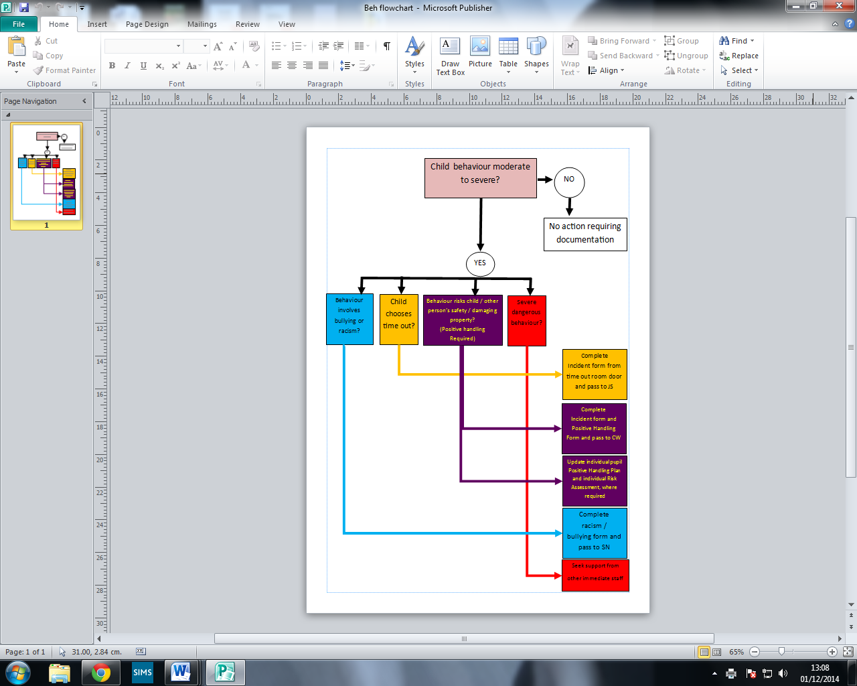
Appendix 2
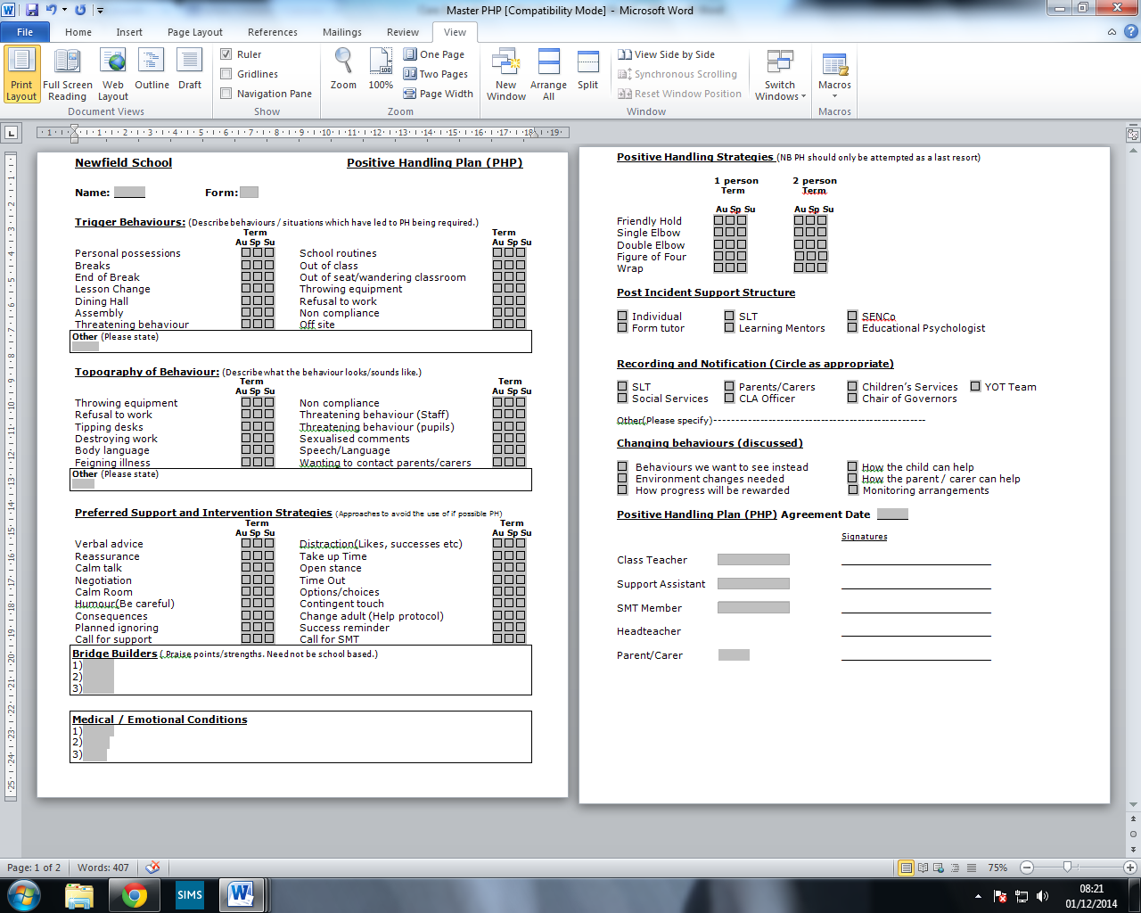

Appendix 3

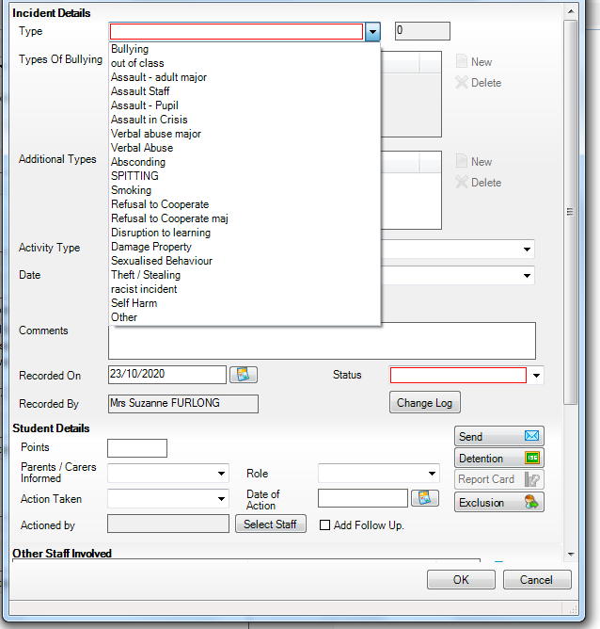

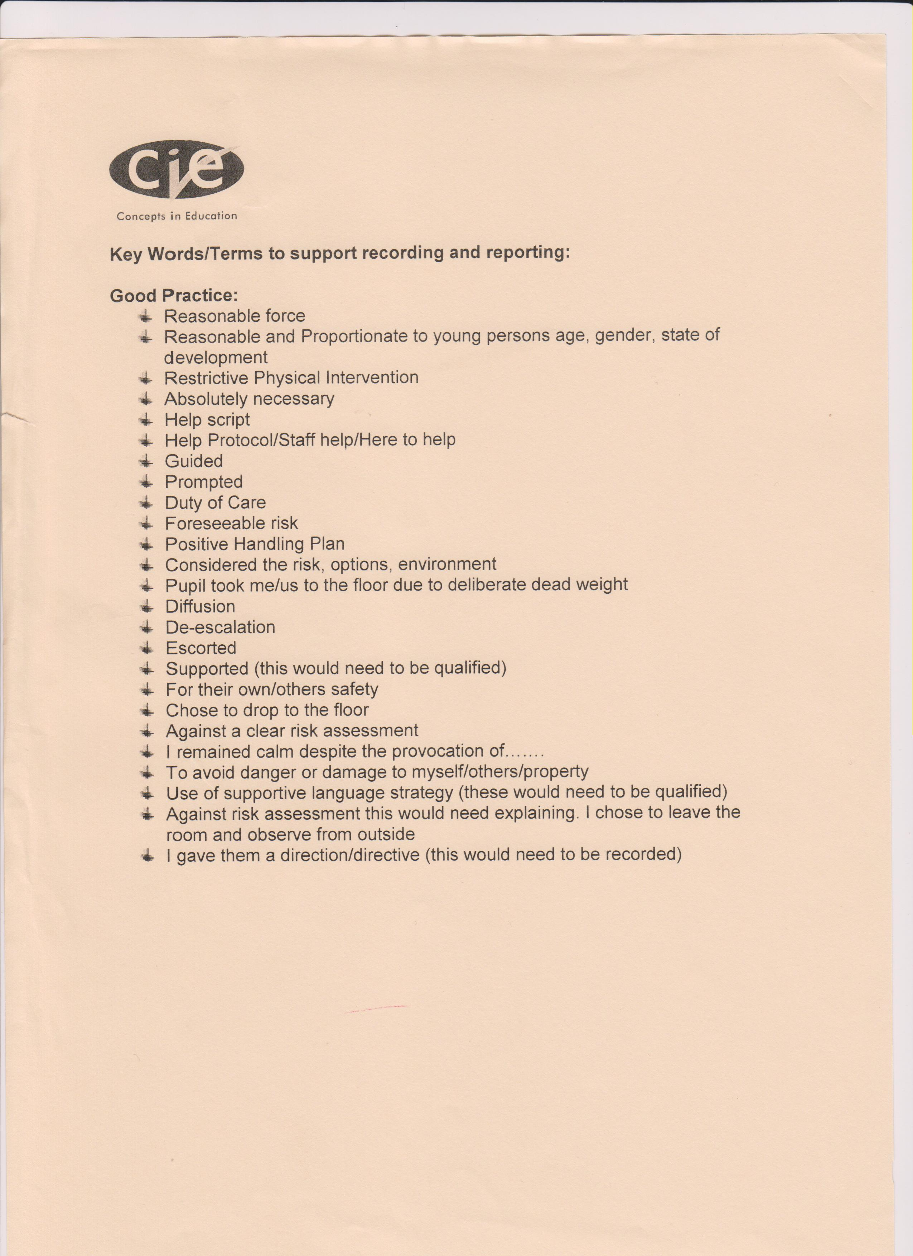
Appendix 4

Newfield School

RECORD OF THE USE OF REASONABLE FORCE
ALL staff involved in an incident that involves positive handling either in the hold or as a witness must complete this form as soon as possible.
This MUST be saved on the staff shared drive and CPOMS.
(No later than 24 hours following the incident.)

The Headteacher’s monitoring comments will follow later.

This is a legal document; please ensure it is FULLY completed and legible

PERSONAL DETAILS:

Pupil Name |  | Year Group
Date of Incident |  | Place of Incident  Ref No:
Reporting Staff |  | Staff Holding
Staff Witnesses |  | Time:
Looked After Y/N |  | Excluded as a result Y/N

RECORD OF INCIDENT

Reason why Reasonable Force was thought necessary:

Was the child concerned liable to injury? Yes / No
Were other children liable to injury? Yes / No
Were staff liable to injury? Yes / No
Was property about to be damaged? Yes / No
Was good order prejudiced? Yes / No
Was the child trying to abscond? Yes / No

Other reasons:

Context – What was happening when you arrived? Staff/ Pupil

What techniques were used to prevent positive handling?
DE ESCALATION
(Diversion, Distraction and De-escalation Techniques)

Verbal advice and support |  | Firm clear directions
Reassurance |  | Success Reminders
Calm Talking / Stance |  | Planned Ignoring
Humour |  | Negotiation
Distraction |  | Transfer Adult
Reminders about Consequences |  | Withdrawal Directed
Withdrawal Offered |  | Use of help script

FULL INCIDENT REPORT

Please give a concise report about the full incident at which you were involved in hold or as a witness. Where possible state the point of arrival, what was happening on arrival, how did the incident develop, dynamic risk assessment, who was holding and what holds were used. Did you walk in hold, why?

PHYSICAL INTERVENTIONS ATTEMPTED

Friendly Hold |  | Double Elbow (two people)
Single Elbow (One person) |  | Single Elbow to knees
Single Elbow (Two people) |  | T Wrap
Sitting Single Elbow (Two people) |  | Seated T Wrap
Double Elbow (one person) |  | Single elbow 2 person seated.
 |  | Walking

POSITIVE HANDLING

How long did the physical intervention last
Which members of staff held the pupil.
State who held which body part
Medical Intervention
Was the child’s breathing/Circulation checked during incident?
Did the child require First Aid? (report to be attached )
Did the pupil have any bruises or injuries?
Did the adult/s require First Aid? (report to be attached)
Did the adult/s have any bruises or injuries?
Damage to property
Was there any damage to property reported?

POST COMMUNICATION

 | Yes/No | Letter/Phone Call | By Whom
Have parents/carers been Informed Letter/Phone call
Please list External Agencies to be informed
Are there any further actions or consequences?
As a direct result of this incident has the PHP/ Risk assessment been changed?

Repair and Reflection with pupils
(How was the situation resolved?)
Did the pupil return to activity?

SLT Overview/Actions:

FOLLOW UP – STAFF

Did a staff debrief take place? | Yes/No
If yes at whose request?

Any member of staff who has been involved in any form of incident including Positive Handling may access support through the staff wellbeing clinic.

DEBRIEFING  Name of staff member | BY WHOM | COMMENTS / FURTHER ACTIONS REQUIRED

Incident Signed off by:
Date / Time

HEADTEACHER MONITORING COMMENTS:

Was sufficient / appropriate de-escalation undertaken? ( )
Were there grounds for use of physical control? ( )
Were approved physical controls used? ( ) Has appropriate / sufficient post incident action been taken? ( ) Is the record keeping comprehensive and complete? ( )
Were all relevant people informed? ( )
Were there any staff / pupil complaints about the incident? ( )

Other comments by the Headteacher:
…………………………………………………………………………………………………………………

………………………………………………………………………….………………………………………

Signed:……………………………………. C WHELAN, Headteacher Date:……………………………………..

Appendix 5

